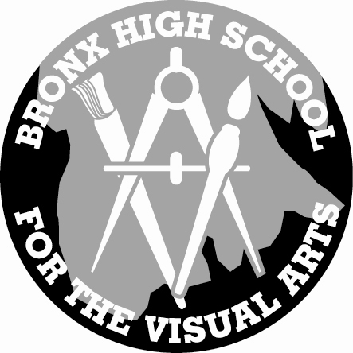
Bronx High School of Visual Arts

2040 Antin Place, Bronx, NY 10462
(718) 319 – 5160 – Fax (718) 319 – 5165 – WWW.BHSVA.ORG
Dr. George York, Principal

CALENDAR OF EVENTS – Monday, September 21st to Sunday, October 4th
DATE | ACTIVITY | COMMENT
Mon.
Sept. 21
Tue.  Sept. 22 | Special Education Meeting  Extended School Day | 9am – Room 206  2:40 – 3:30 All teachers
Wed.  Sept. 23 | Dr. Phil Arbolino  SAPIS Counselors Meeting  Pupil Personnel Committee Meeting  Extended School Day | AP Teachers – 8:30 – 3PM  Library – 8 – 12 Mr. Selby in charge  9:10 Room 206  2:40 – 3:30 All teachers
Thu.  Sept. 24 | LLSO College Readiness Team  Extended School Day  SLT  PTA Back to School NIght | 1 – 4PM – Zerega, Room 63  2:40 – 3:30 All teachers  4 – 5PM  6PM
Fri.
Sept. 25
Sat.
Sept. 26
Sun.
Sept. 27
LOOKING AHEAD
DATE | ACTIVITY | COMMENT
Mon.  Sept. 28 | Yom Kippur | No School
Tue.  Sept. 29 | Extended School Day | 2:40 – 3:30 All teachers
Wed.  Sept.30 | Extended School Day | 2:40 – 3:30 All teachers
Thu.  Oct. 1 | Extended School Day  Interim Progress Report due for students at risk or failing  Deadline for NOV. SATs | 2:40 – 3:30 All teachers  9am – in Room 101
Fri.  Oct. 2 | Surdna Partnership | Evening – Carol Sun and G. York
Sat.
Oct 3
Sun.
Oct 4
LOOKING AHEAD
OVERDUE: Handbook Certification
3 Absentee Lesson Plans to D. Weinberg
Reminder; Course contract and Curriculum Map due for PTA Back to School Night
Monday, October 5 – Faculty Meeting
Monday, October 12 – Columbus Day, No School
October 14th PSAT Day for all Sophomores and Juniors – 9:30 – 11:30 schedule to follow
Monday, October 19 – Early Dismissal for students -Professional Development 1:40 – 3:30
End of Marking Period 1 – October 21
Grades Due – October 23
Open School Evening and Afternoon – October 29, 30
Halloween Dance - October 30th
Tuesday, November 3, Election Day, Professional Day at Bronx Museum of Art
Advanced Placement Workshop at Stuyvesant HS, Registration necessary
November 7th – SAT test
Veteran’s Day – November 11 – No school
Mid Term Exams – November 9 – November 18 – schedule to follow
November 14 - National Portfolio Day at Pratt
November 26 - Thanksgiving

Fire Drills will be coming soon!

